VGM Guide for Booking Agent

In E-service, there is VGM Management menu.
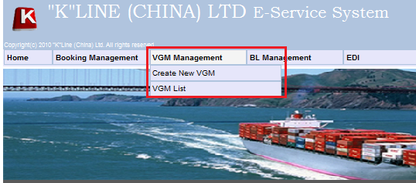
- [Create New VGM] for input VGM data
- [VGM List] – search and view submitted VGM data.

Create New VGM
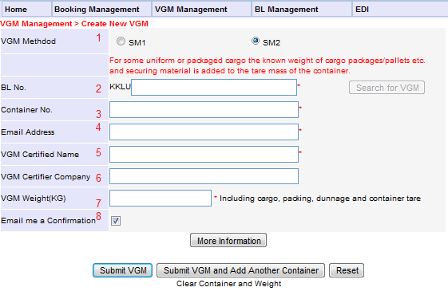
Item 1-5 and 7 are mandatory items.
Item 1: Please select SOLAS verification method 1 or SOLAS verification method 2
Item 2: If BLNO not belong to BA, system will show invalid BL
Item 3: If container number not existed in Master and BK not indicated container is SOC. Then system also shows the invalid CNTR. Not allow submit VGM data.

For SM2
After input container [1], web will show [2] if tare weight of container is registered in system.
Input gross weight [3] and then click “Calculate VGM” button [4]. System will auto calculate and show the VGM Weight result in [5].
Note: VGM Weight still allow to edit.
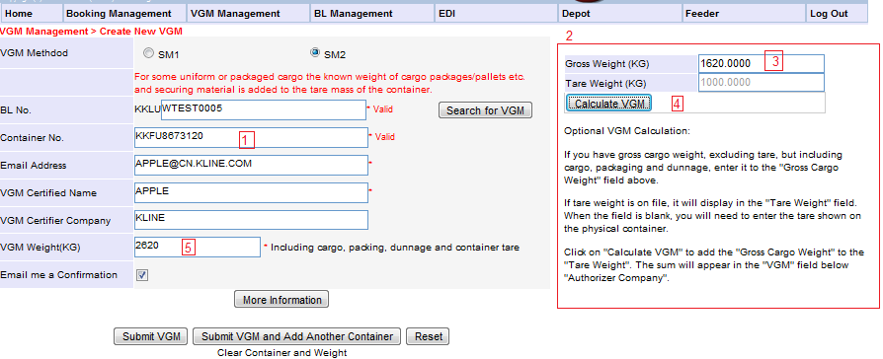
Item 4: VGM Email Address
Item 5: VGM Certified Name
Item 6: VGM Certifier Company
Item 7: VGM Weight in KGS
Note: System will base on user login details, default the email address/ VGM Certified Name/VGM Weight.
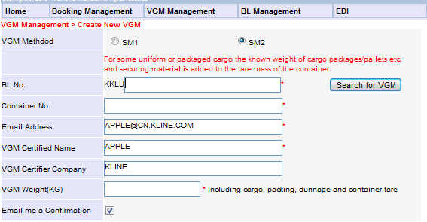

Click [More information]
For SM1: User could input additional details of VGM, such as VGM Verified date /VGM Certificate ID /VGM Certified Address. 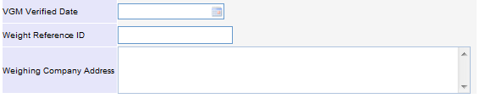
For SM2: User could input additional details of VGM, such as VGM Verified date /VGM Certificate ID /VGM Certified Address are optional items.
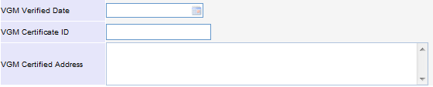
[Submit VGM] button
System will validate the input value, if not problem will save it. Then all information will be clear
[Submit VGM and Add Another Container] button
If you want to input other container number under same BLs, you could click [Submit VGM and Add Another Container] button.
Web will keep all details except container number and VGM Weight.
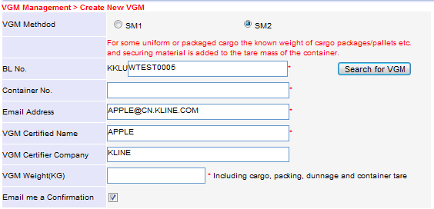

VGM List
To Search or view submitted VGM data.
Search criteria could be by BLNO / Container number or submit date range.
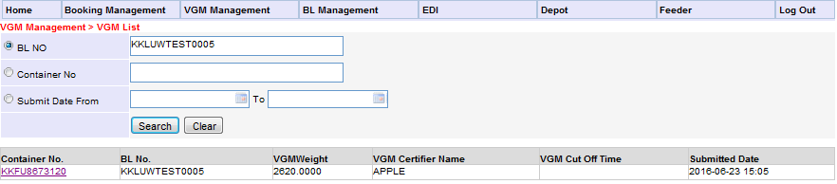
Click the container number to view the VGM detail and edit.
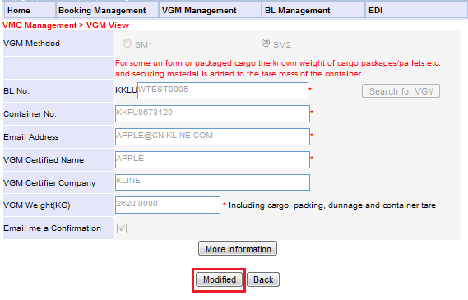

EDIT VGM data

There are two methods.
Method 1:
Search the VGM record in VGM List. Please refer to VGM List section.
Method 2:
VGM Management > Create New VGM
Input BLNO and Container number. If VGM data already existed, system will show the message box to confirm user whether modify previous record or not.
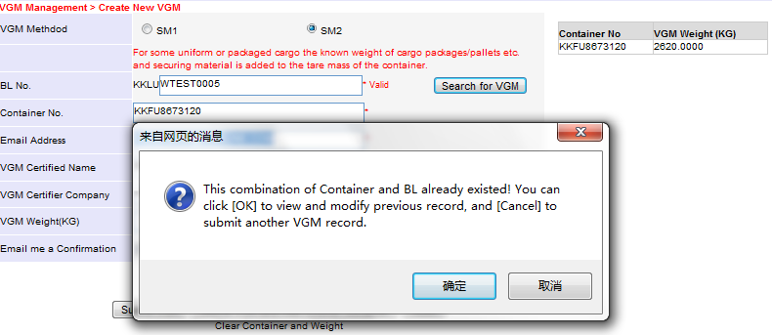
Click [Yes], the web will show the previous record details,
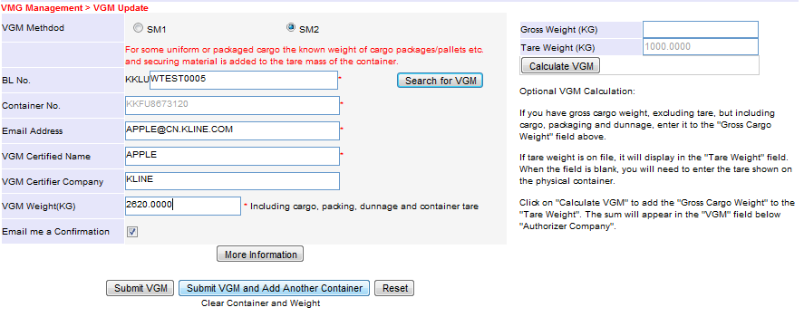
Click [Cancel], system will reset the page.

